Google Classroom

**Online Learning Platform**

Use-Case Specification: Complete assignment

Version 1.1

Revision History

| **Date** | **Version** | **Description** | **Author** |
| --- | --- | --- | --- |
| 5/12/2021 | 1.0 | Initial version | Nguyen Nhu Hong Phuc |
| 9/12/2021 | 1.1 | Final version | Nguyen Nhu Hong Phuc |
|  |  |  |  |
|  |  |  |  |

Table of Contents

1. Use-Case Name 3

1.1 Brief Description 3

2. Flow of Events 3

2.1 Basic Flow 3

2.2 Alternative Flows 3

2.2.1 < First Alternative Flow > 3

2.2.2 < Second Alternative Flow > 3

3. Special Requirements 3

3.1 < First Special Requirement > 3

4. Preconditions 3

4.1 < Precondition One > 3

5. Postconditions 3

5.1 < Postcondition One > 3

6. Extension Points 3

6.1 <Name of Extension Point> 3

Use-Case Specification: Complete assignment

# Use-Case Name

## Brief Description

* This process for user to complete class assignment in Google Classroom
* For the students only
* The purpose : helping users to finish class assignment on time in the Google Classroom

# Flow of Events

## Basic Flow:

The first thing you need to do is access your account in classroom.google.com and enter a specific classroom . There are several things for you to do the assignments . The first thing to keep in mind is

Stream is the main part to tell the students for students to know if the assignment has been assigned or not .

 or  icon is the assignment that the teacher give to students that students can see clearly at the Stream Screen in the course . Or the upcoming sections have the  button when students click the button the assigned section appeared the list of homework that lectures have given to the students such as the picture below .

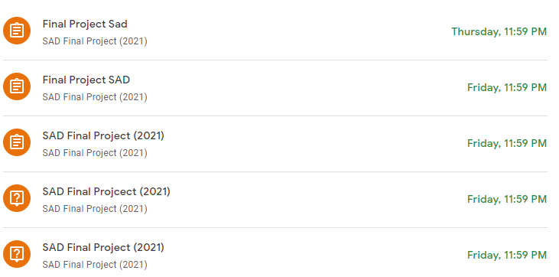

The final is clicking the classwork have assignments that students should be taken in a specific day , also the interesting things is students can take the multiple choice question directly just by clicking to the assignments and the students can submit the attempt right away

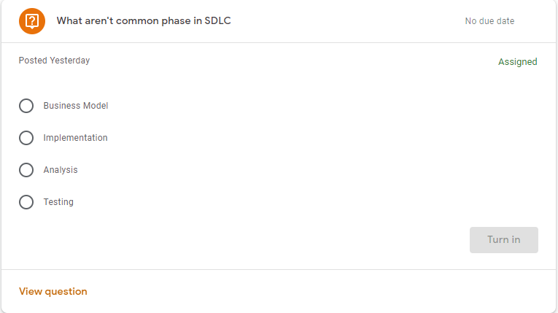

When accessing into the assignments , the questions assignments you can select the answers and to finish the attempts by clicking the Turn in button. Also , the other questions will have the option to upload file or create it directly in the submission box – can easily to edit or insert anything . Mark as done is also an option to finsish the attempts from the students as well. The comments have 2 available options  which a public comment that everyone can see while which only for lecturer-view only.

## Alternative Flows

None

# Special Requirements

None

# Preconditions

None

# Postconditions

None

# Extension Points

None